**Abstract**

A volume of a fixed mass of air and a volume of air at a fixed atmospheric pressure were measured as a function of temperature. The relationship between pressure, temperature and volume was studied using the ideal gas law formula. The data collected was analyzed using the ideal gas law to determine absolute zero temperature.

**Introduction**

The determination of absolute value by obtaining temperature readings of a volume of gas using two types of thermometers is the goal of this experiment. By holding a certain parameters of the ideal gas law constant, the data will be compared to the model to confirm the relationship of pressure, volume, and temperature. The first thermometer holds atmospheric pressure constant and the change in volume will indicate the temperature. The second apparatus allows pressure to change while the volume is held at a constant. The measured temperature of the mass of air at a fixed volume should provide sufficient data for the linearity of the temperature as a function of pressure to be determined.

The ideal gas law is:

*PV=nRT*

Where,

*P = pressure*

*V = volume*

*n = number of moles*

*R = gas constant*

*T = temperature*

Should all these variables be measured with accuracy, the model should provide enough data for a linear regression model to determine absolute zero temperature within a minimal margin of experimental error.

**Procedure**

**Part One**

A constant pressure gas thermometer (fig1) was used to test the linearity of the ideal gas law. This thermometer was composed of a long glass rod containing gas sealed at one end by a rubber stopper, and at the other a small quantity of mercury. Surrounding this inner chamber was a vestibule through which the authors were able to run water at various temperatures. During this process, the gas expanded or contracted, moving the mercury such that ambient pressure was maintained.

The authors began by recording room temperature and the associated length of trapped gas in the thermometer. A steam generator was filled up halfway with water and heated by a hot plate to its boiling point. While the water was left to heat up, ice cold and warm water were independently run through the thermometer. A conventional metal thermometer was used to check the stability of the temperature of the fluid as it was passed through the device. Once it had sufficiently stabilized, the length of the trapped gas was recorded. This process was repeated during a third trial, wherein steam was passed through the vestibule.

Part Two

The linearity of the ideal gas law was tested once more, using a constant volume gas thermometer. This apparatus was composed of a hollow, metal ball filled with gas, sealed by a valve and a pressure gauge measuring kiloPascals (kPa). A removable pressure release cap was fixed along the neck, such that the pressure of the gas inside was able to equilibrate to ambient conditions prior to experimentation.

During each trial, the hollow metal ball was placed into either ice water, warm water, or boiling water, each contained by a steel beaker. Contact with the walls of the beaker was avoided. An electric thermometer was taped to the outside of the metal ball, and a glass thermometer was used to measure the temperature of the water during each trial. Once there was an observed stabilization of the ball’s temperature fluctuations around the water temperature, the pressure readings of the gauge were recorded.

**Results**

*Mercury Thermometer (constant pressure)*

Four measurements were taken for water temperature and 1-dimensional volume (position of the mercury drop) for a total of $$8$$ measurements. Pressure was held constant at $$101.325 kPa$$ as was the amount of gas, $$n$$.

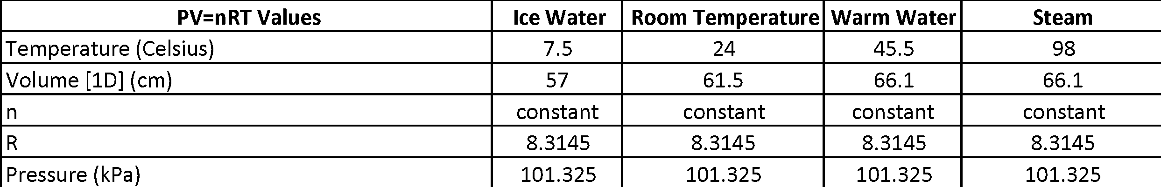

An initial volume of $$61.5cm$$ at a room temperature of $$24℃$$ was recorded. The first container, filled with ice water, was poured in the funnel until the thermometer reached equilibrium. Volume of the mercury drop lowered to $$57cm$$ at a temperature of $$7.5℃$$. Warm water was poured into the funnel next, again giving the thermometer time to reach equilibrium. Once equilibrium was reached, the mercury drop had reached a volume of $$66.1cm$$ at a temperature of $$45.5℃$$. Following the hot water, steam was routed into the thermometer, giving a volume reading of $$66.1cm$$ and $$98℃$$. Figure 1 shows the plot of this data with a linear regression model.

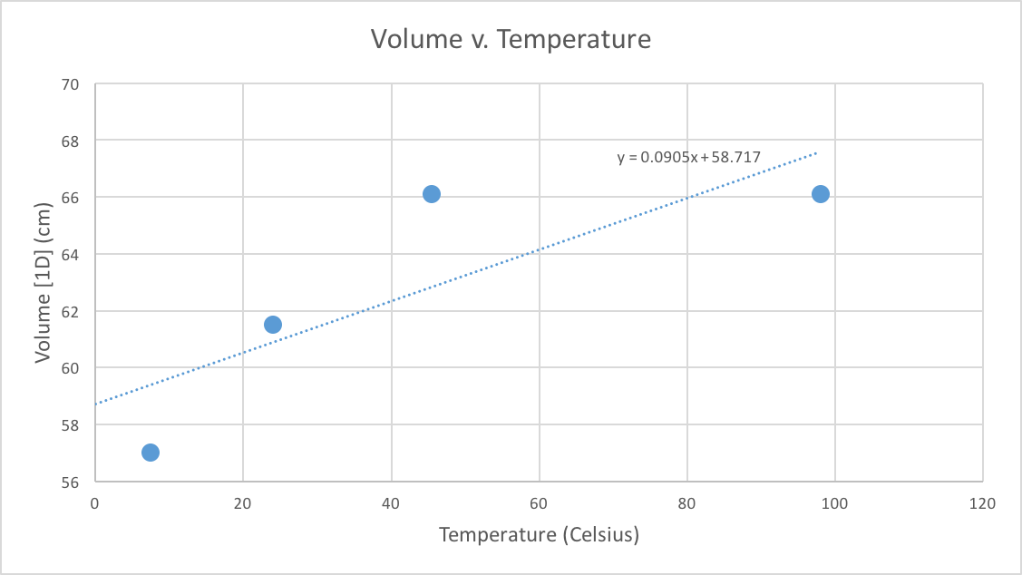

*Figure 1: Mercury Thermometer Volume v. Temperature*

*Constant Volume Gas Thermometer (Sphere)*

Similar to the constant pressure mercury thermometer, there were 4 measurements taken for two different parameters in this portion of the experiment. The sphere was held at constant volume. Four measurements were taken for both sphere temperature ($$℃$$) and pressure ($$kPa$$), resulting in a total of measurements. After all data was obtained, a calculation for absolute zero temperature ($$℃$$) at $$P=0$$ was made.

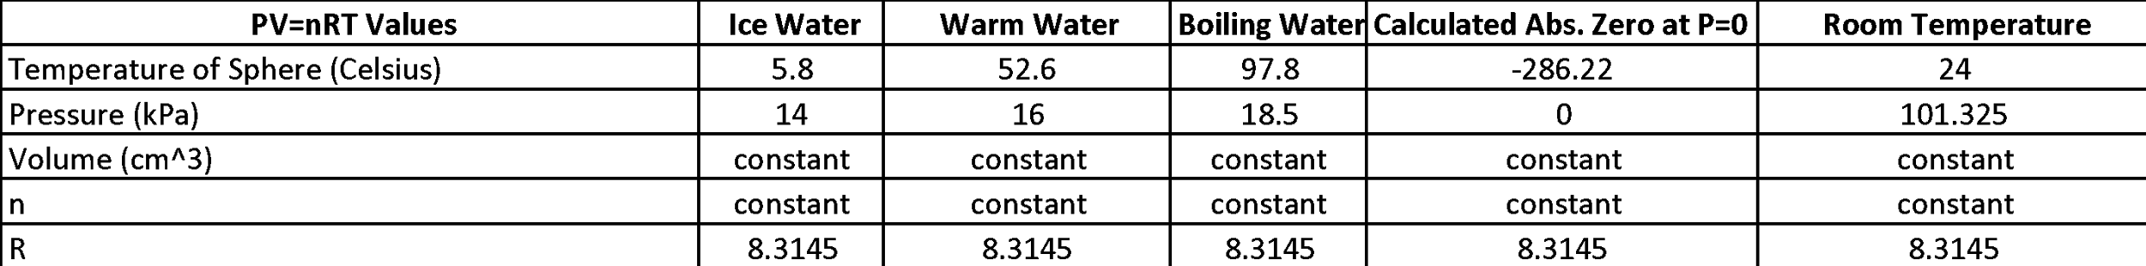

With the sphere submerged in ice water, it’s temperature was $$5.8℃$$ with a pressure of $$14kPa$$. Following the ice water was warm water submersion with a temperature of $$52.6℃$$ and pressure of $$16kPa$$. This trend was expected to continue as the temperature of the water increased. At boiling, the temperature was recorded to be $$97.8℃$$ with a pressure of $$18.5kPa$$.

Figure 1 below shows the plotting of the data gained from experiment, along with a calculated value of what absolute zero would be given our values and a linear regression model1.

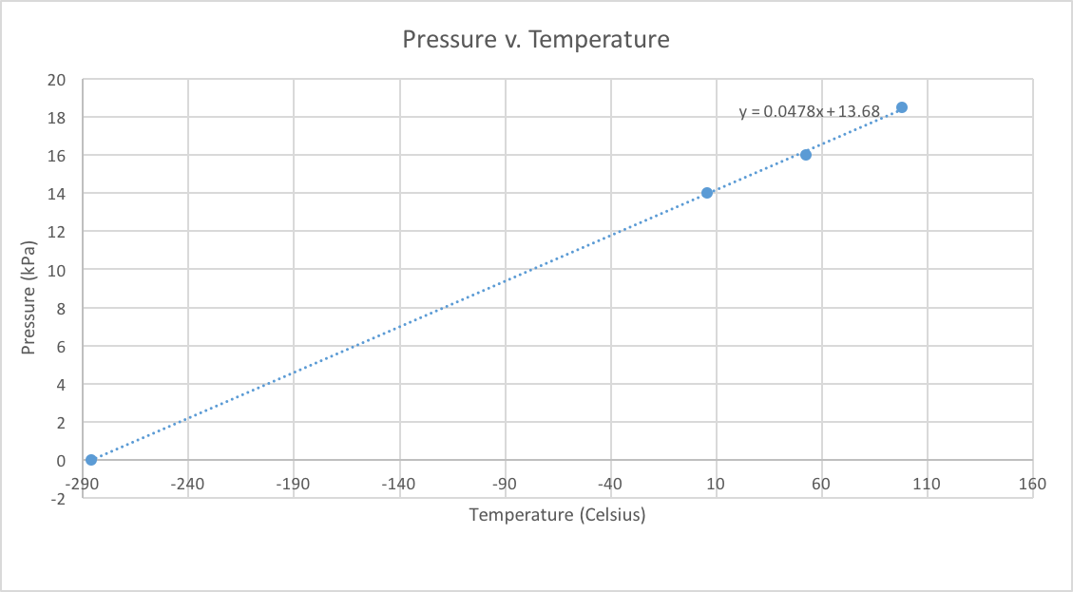

*Figure 2: Pressure v. Temperature with linear regression & absolute zero calculation*

The linear regression shows that, using the collected data, absolute zero temperature in Celsius is $$-286.22℃$$. There is an error margin of $$4.8\%$$ when compared to the known value of absolute zero, $$-273.15℃$$.

Discussion  
  
Conclusion

Appendix

1. This value was calculated using the following expression: $$t_{abs.zero}=\frac{(t_{b}-t_{f})(-P_{f})}{P_{b}-P_{f}}$$ where subscripts $$f$$ and $$b$$ represent *freezing* and *boiling*, respectively.